Ex.No. 13: V2X Latency Comparison

Objective 1:
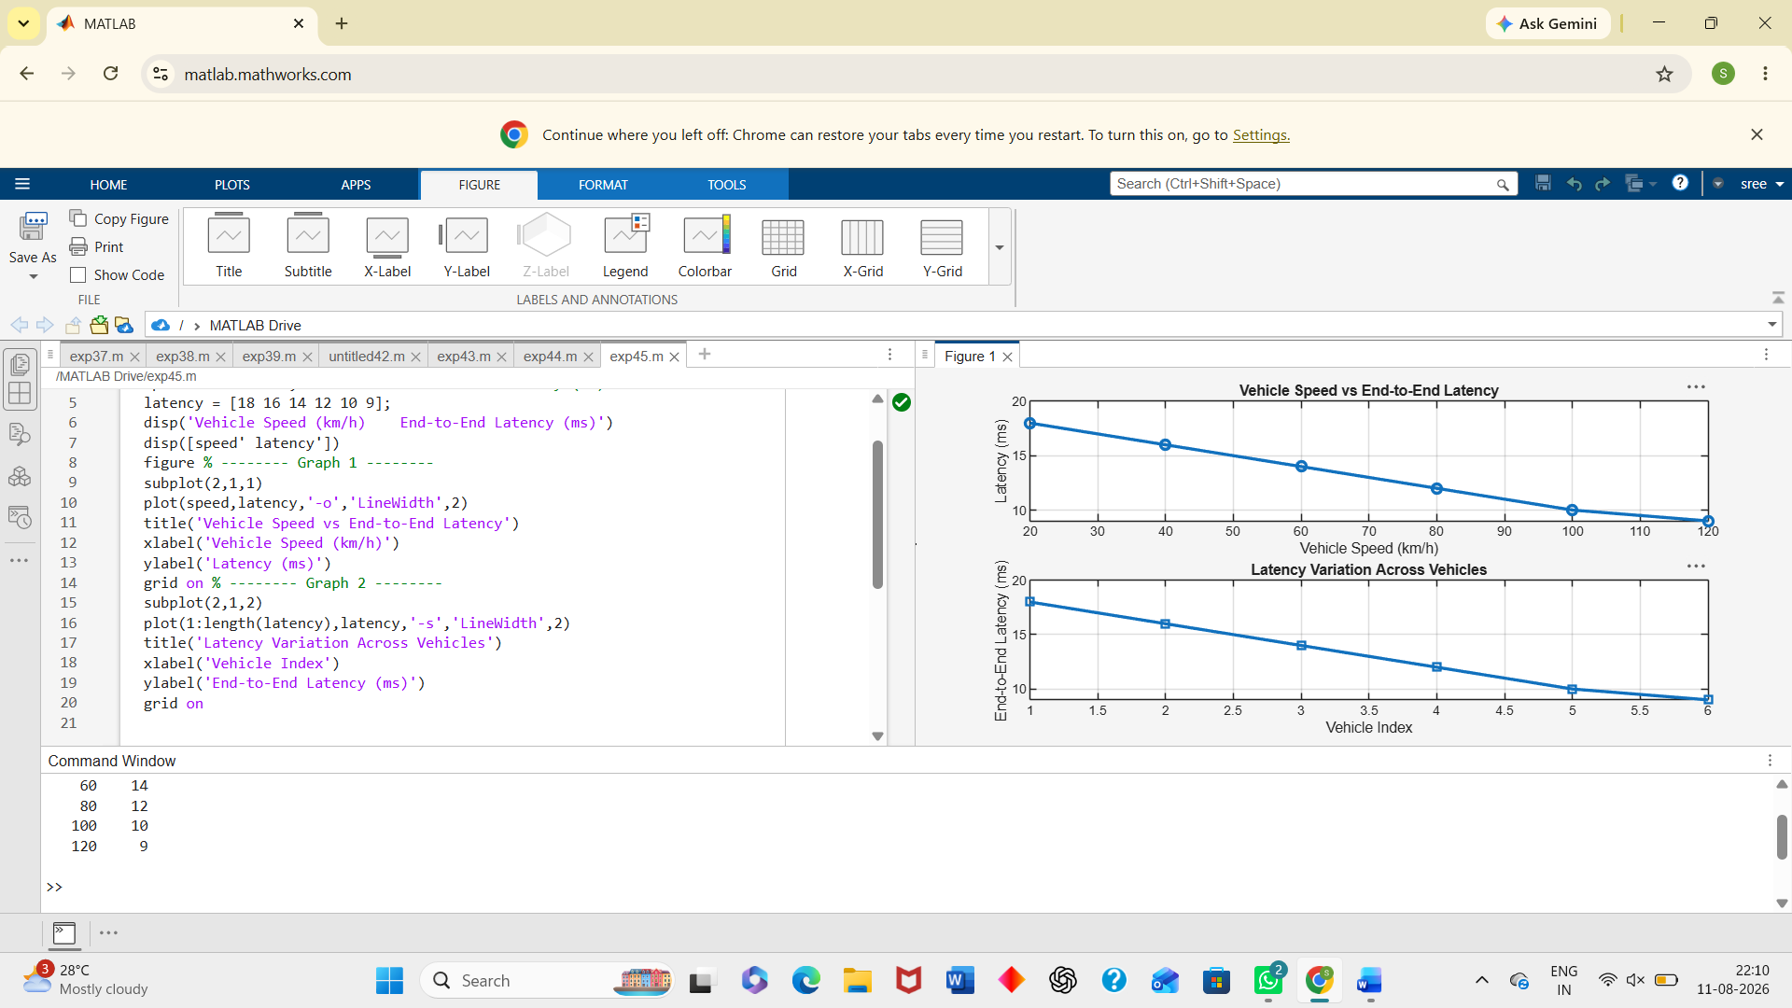
Objective 2:
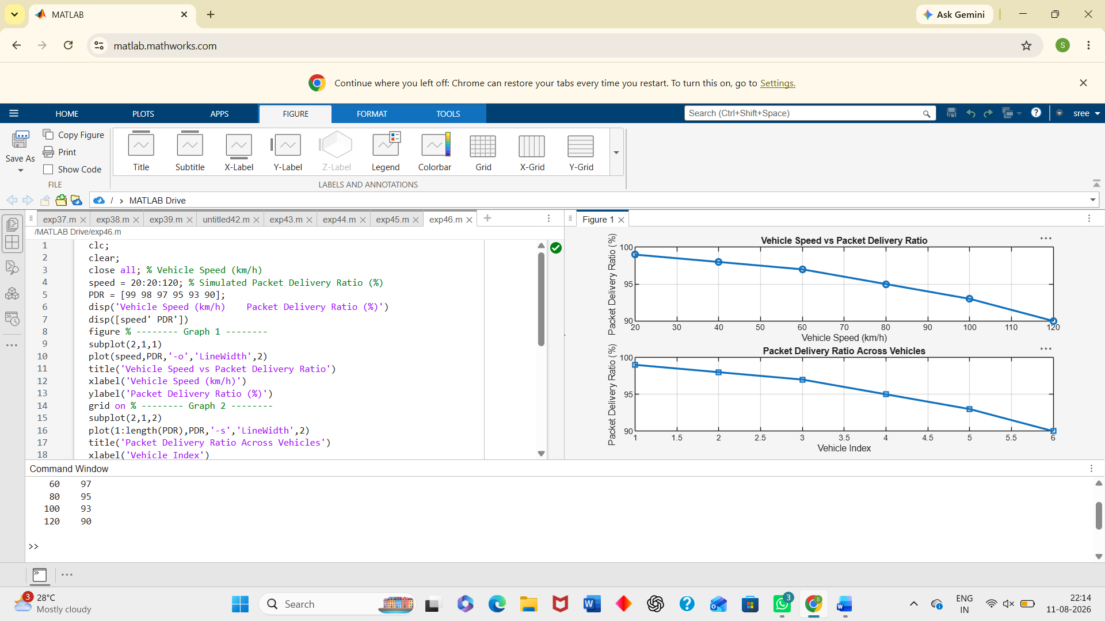
Objective 3:
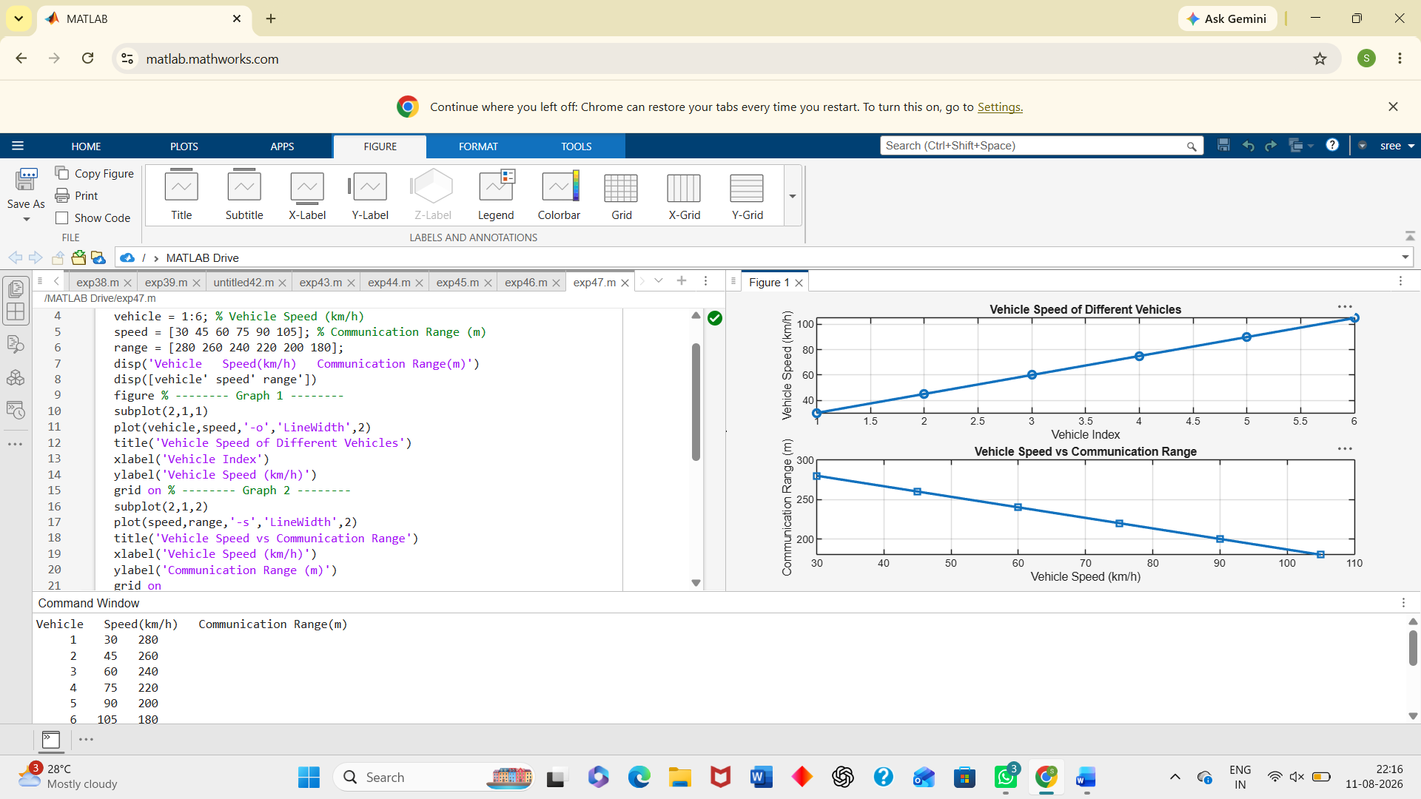
Result:
The End-to-End Latency (ms) of the V2X communication system was successfully analyzed, demonstrating efficient data transmission with low communication delay. The Packet Delivery Ratio (PDR %) was evaluated and showed high packet delivery reliability under different vehicle operating conditions. The impact of Vehicle Speed (km/h) on V2X communication was successfully studied, indicating that higher vehicle speeds can influence communication range, latency, and overall network performance.

